**Types of JavaScript objects**

There are **2** types of JS objects:

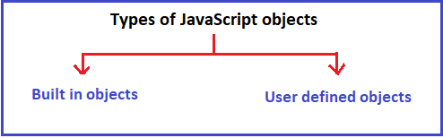

**First:** **Built in objects:**

Built in objects are predefined objects present in the language and it responsible for handling some specific task.

**Examples on built in objects:**

* **Common reference objects:** Number, Boolean, String, Math, Date, RegExp, Array, Function, Object,
* **DOM (Document Object Model) reference objects:** Document, Elements, Attributes, Events, Style,
* **BOM (Browser Object Model) reference objects:** Window, Navigator, Screen, History, Location, Storage,
* **Other reference objects:** Global, Error, Conversion, Storage, Arguments, Statement etc…

**Second:** **User defined objects**

**Note:**

1. Every JavaScript objects are descendent of an object called Object.
2. JavaScript Object object is the father of every object present in JavaScript.